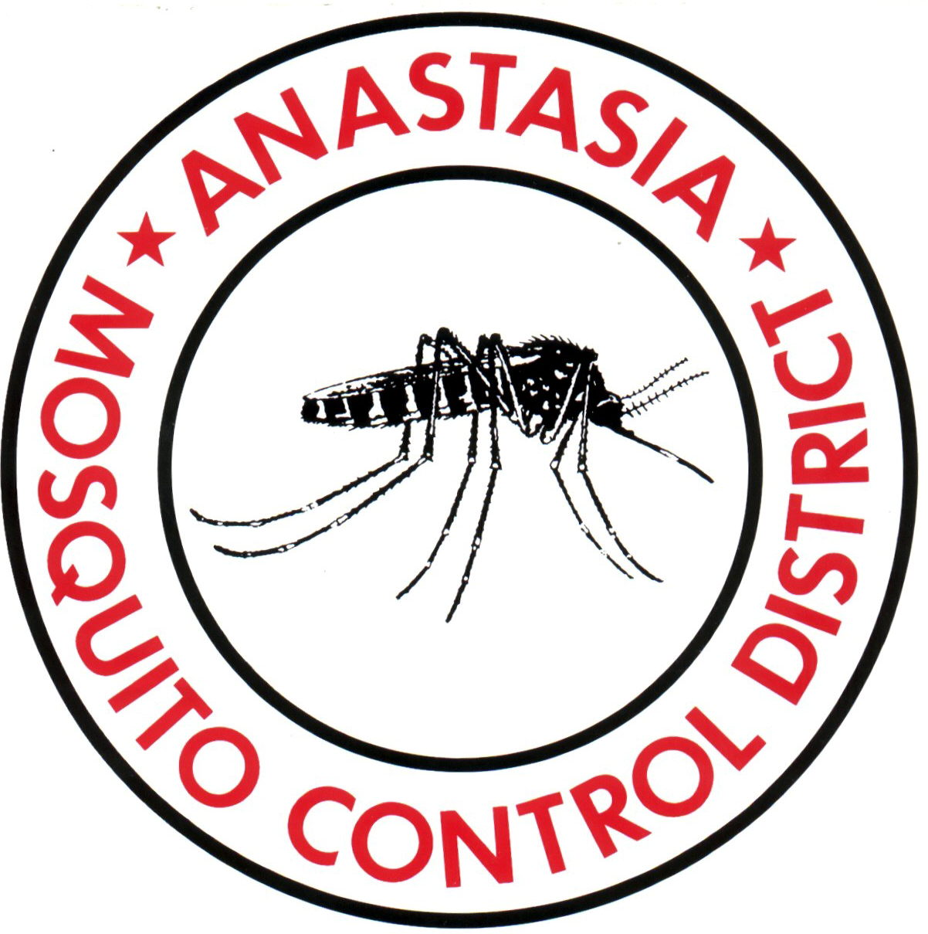
ANASTASIA MOSQUITO CONTROL DISTRICT

ST. JOHNS COUNTY

PROPOSED AGENDA

Thursday, June 17, 2021
5:00 P.M.

Invocation and Pledge:

By Commissioner Mrs. Brandhorst

Proclamation by Commissioner Mrs. Becker

Consent Items: Approval Of:
- Treasurer’s Report
- Vouchers (Cancelled Checks)
- Chemical Inventory
- Minutes: Regular Board Meeting, May 13, 2021 at 5:00 P.M.
- Renewal of auditor contract for auditing FY20/21
- Approval Mrs. Becker use the airline tickets credits to visit Rutgers University’s Center for Vector Biology, New Jersey or Puerto Rico Vector Control Agency, San Juan.
- Payroll software update
- Quarterly budget analysis
- Budget Amendments

New Business:
- Report about school research project … Commissioner Mrs. Becker (15 min)
- Discussion and approval of the RFP for the SIT mass rearing facility … Business Manager … Mr. Weaver (15 min)

Unfinished Business:
- Discussion and approval of the FY 21/22 draft budget … Director Dr. Xue & C.F.O. Mr. Hanna (30 min). Please bring your draft budget books distributed on May 13.

Reports
- Director
- Attorney

Commissioner Comments:

Attachments: For Information Purposes Only

