The 21st Arbovirus Surveillance
and Mosquito Control Workshop

Organized by AMCD and Sponsored by FMCA & Gulf South V.E.C.T.O.R.

AMCD’s Complex at:
120 EOC Drive, St. Augustine, Florida, 32092

March 2nd – 6th, 2026
www.amcdsjc.org
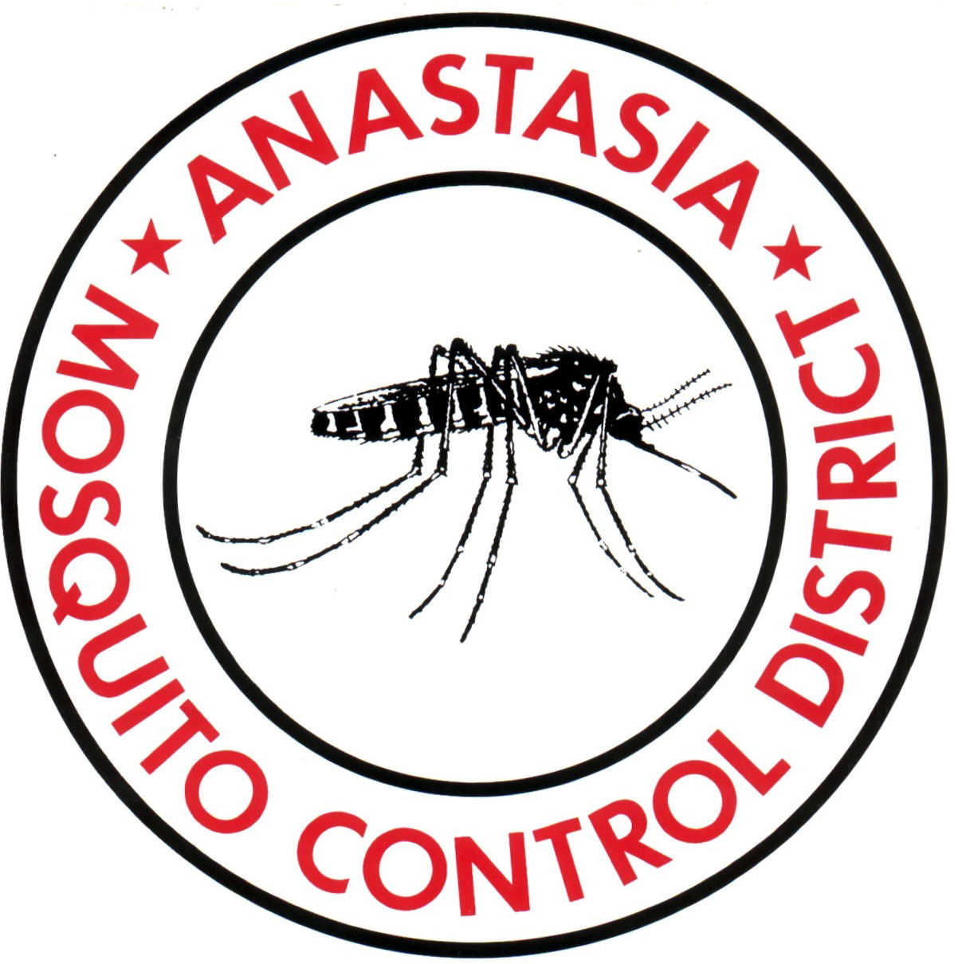


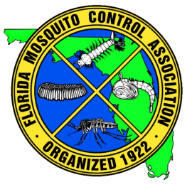

The 21st Arbovirus Surveillance
and Mosquito Control Workshop inconjunction with the florida mosquito control association fly-in class

Sponsored by AMCD, FMCA, & Gulf South V.E.C.T.O.R.

Being held at AMCD’s Complex at:
120 EOC Drive, St. Augustine, Florida, 32092
March 2nd – 6th, 2026
www.amcdsjc.org

PROGRAM AGENDA (tentative)

MONDAY, MARCH 2-3, 2026

Florida mosquito control association’s aerial workshop, helicopter hangar

tuesday, march 3, 2026

2:00 P.M. 4th Annual aMCD’S ADJUNCT/CONSULTING/collaborating MEETING (A.I. TECHNOLOGY, E-DNA, SIT/IIT, ATSB, New insecticides and repellents IN Board room)

5:30 P.M. Group Dinner at Ruby Tuesday (sponsored by Clarke)

wednesday, March 4, 2026

7:30 A.M. Registration at the Disease Vector Education Center/Building # 450 … AMCD Staff.

Welcome to a tour of the Disease Vector Education Center, SIT mass-rearing facility, and other facilities during the workshop.

Moderator: Dr. Rui-De Xue, Executive Director, AMCD, St. Augustine, FL

Panel Session:

8:30 A.M. Welcome & Introduction … Ms. Gayle Gardner, Chairperson of AMCD Board of Commissioners, and Dr. Peter Jiang, President of the FMCA

8:40 A.M. Keynote Speaker: Keeping up with evolution and emergence of new arboviruses: An ongoing challenge for mosquito control … Dr. John Glenn Morris, Professor, University of Florida/EPI. Gainesville, FL

9:10 A.M. Keynote Speaker: Opportunities and challenges of the sterile insect techniques (SIT) for the control of Aedes mosquitoes and arboviral diseases … Dr. Florence Fougue, Senior Scientist, Switzerland, Adjunct Entomologist, AMCD, St. Augustine, FL

9:40 A.M. Guest Speaker: Landscape and meteorological influences on oviposition of Asian tiger mosquito in
north Taiwan … Dr. Neoh Kok Boon, Professor, Department of Entomology, National Chung
Hsing University, Taiwan

10:10 A.M. Break

Moderator: Dr. Kenneth Linthicum, Adjunct Senior Vector Biologist at AMCD, Retired Center Director, USDA/CMAVE, GAINESVILLE, FL

10:30 A.M. Otherwise on the DWFP uniform study … Dr. James Harwood, CDC/NCEZID/DPDM/EB, Atlanta, GE

10:50 A.M. Overview of applied science technologies activities in Lee County Mosquito Control District … Dr. Jim Dunford, Research Director, Lee County Mosq Control District, Lehigh Acres, FL

11:10 A.M. AI and citizen science solutions for next-generation mosquito surveillance … Dr. Ryan Carney, Associate Professor of Digital Science, National Geographic Explorer, Department of Integrative Biology, University of South Florida, Tampa, FL

10:30 A.M. New technology for Aedes mosquito control … Dr. Sylvie Manguin, Professor, DRI, Universite Montpellier, France

11:50 A.M. Update on programs of the Bureau of Entomology ... Dr. Leroy Whilby, Bureau Chief, Dr. Bradley A. Danner (Presenter), Biological Administrator III/SES Coordinator, Division of Plant Industry, DACS, Gainesville, FL

12:10 P.M. Lunch break (HELICOPTER HANGAR, provided by Veseris & Central Life Science)

PROGRAM SESSION:

MODERATOR: Dr. Florence Fougue, Senior Scientist, Switzerland, Adjunct Entomologist, AMCD, St. Augustine, FL

1:30 P.M. Enhancing arboviral Research and Surveillance Capability of West Africa countries to address growing arboviral disease threat: the role of West African Aedes Surveillance Network (WAASuN) … Dr. Samuel Dadzie¹, Jewelna Akorli¹, Joseph Chabi^{,2}, Sellase Pi-Bansa¹, Emelda Eloy³, Andy Asafu-Adjaye¹, Mawlouth Diallo⁴, Nicole Dzuris⁵, Rebecca Levine⁵, Audrey Lenhart⁵, All WAASuN members^{6,}Parasitology Department, Noguchi Memorial Institute for Med Res, University of Ghana, Accra, Ghana, sdadzie@noguchi.ug.edu.gh

1:50 P.M. Overview of drone for mosquito control in the USA … Mr. Joel Buettner, General Manager, Placer Mosquito Control District, California, Vice President of the AMCA

2:10 P.M. The Florida DACS mosquito control program update in 2025 … Ms. Marah Clark, Environmental Administrator, Entomology and Pest Control Section, DACS, Tallahassee, FL

2:30 P.M. American Mosquito Control Association’s update, 2025 … Mr. Robert Cartner, Director, Beaufort County Mosquito Control, Beaufort, SC. Regional Director, AMCA

2:50 P.M. Update on the Gulf South V.E.C.T.O.R. program… Dr. Claudia Riegel, Director, City of New Orleans Mosquito, Termite and Rodent Control Board, New Orleans, LA

3:10 P.M Update on evaluation of CapGel arbovirus detection methods … Ms. Uvina Allen, Biotech, AMCD, St.
Augustine, FL

3:25 P.M Break

Moderator: Dr. Uli Bernier, Adjunct Senior Chemist at AMCD, Retired National Program Leader from USDA/ARS

3:40 P.M. Evaluation of automated trapping tools to collect host-seeking Anopheline and Culicine mosquitoes as an alternative to human landing catch …Mr. Richard Paul B. Malijan, Department of Entomology, Faculty of Agriculture, Kasetsart University, Bangkok, Thailand

4:00 P.M. Dispersal of Aedes aegypti in Urban Environments of Miami-Dade County, Florida … Dr. Hadian Sasmita, Postdoctoral Associate, University of Miami, FL

4:20 P.M. The distribution of Aedes aegypti in Puerto Rico – 2025 update… Jun Soo Bae, UF, Florida Medical Entomology Laboratory, Vero Beach, FL

4:40 P.M. Essential oils and the development of insecticide against mosquitoes … Dr. Daniel Swale, Associate Professor, Department of Entomology, University of Florida, Gainesville, FL

5:00 P.M. Nanoparticle formulations & mosquito control… Mr. Kai Blore, AMCD Lab Manager/UF Ph.D. Student, St. Augustine, FL

5:15 P.M. Overview of a naturcide for mosquito control … Mr. Greg Pettis, Vice President, Med-X, a leader in Green Solutions, Canoga Park, CA

5:30 P.M. End of session

thursday, March 5, 2026

SURVEILLANCE of disease & vectors

Moderator: Dr. Michael Turell, Adjunct Senior Arbovirologist at AMCD. Retired Research Entomologist from the US Army Medical Research Institute of Infectious Diseases

8:40 A.M. 2025 Arbovirus activities in Florida … Dr. Rebecca Zimler, Vector-borne Disease Surveillance Coordinator, Bureau of Epidemiology, DOH, Tallahassee, FL

9:00 A.M. Aedes Mosquito Dynamics Across Zika (2016) and Dengue (2020–2024) Outbreaks in Miami-Dade County. ... Magic Vang, graduate student, University of Miami, FL

9:20 A.M. How does concurrent ingestion of microfilariae and virus enhance virus transmission? … Dr. Michael Turell, Senior Arbovirologist (retired), US Army Medical Research Institute of Infectious Diseases, Fort Detrick, MD

9:50 A.M. Air, water and sediments: Detecting Floridia’s mosquitoes with environmental DNA surveillance, Dr. Dave Duffy, UF/Whitney Laboratory, St. Augustine, FL

10:10 A.M. BREAK

BIOLOGY & ECOLOGY SESSION:

Moderator: Dr. Yoosook Lee, Assistant Professor, University of Florida/FMEL, Vero Beach

10:30 A.M. Investigating Anopheles squamosus, an understudied malaria vector in sub-Saharan Africa … Valerie Nguyen, UF, Florida Medical Entomology Laboratory, Vero Beach, FL

10:50 A.M. The effect of artificial light on larvae and its carry-over in Aedes aegypti mosquitoes … Ms. Yi
Ting Liu, Graduate Student, Department of Entomology, National Chung Hsing University, Taiwan

11:10 A.M. Invasive mosquito surveillance in Lee County, Florida … Mr. Milton Sterling, Surveillance Manage, Lee County Mosquito Control District, Lehigh Acres, FL

11:30 A.M. Toward Ecological Forecasting of Eastern Equine Encephalitis Virus … Dr. Lindsay Campbell, Assistant Professor, UF/IFAS/FMEL, Vero Beach, FL

11:50 A.M. Surveillance of Aedes mosquito population in St. Johns County in 2025 … Mr. Steve Smoleroff, Field Biologist, AMCD, St. Augustine, FL

12:05 P.M. Lunch break (Helicopter Hangar, provided by AMGUARD & Azelis)

Moderator: Dr. Whitney Qualls, Assistant Director, AMCD, St. Augustine, FL

1:10 P.M. Dibrom C and Trumpet EC for aerial application efficacy … Mr. Derek Wright, Public Health, AMGUARD Environmental Technologies, Morrisville, NC

1:20 P.M. Design, concept and preliminary evaluation of portable experiment hut tent (PEHT) for study of mosquito behavior … Dr. Louisa Messenger, Assistant Professor, University of Nevada, Las Vegas, NV

1:40 P.M. Drone application for larvicides in St. Johns County, FL… Mr. Morgan Duett, Assist Supervisor Anastasia Mosquito Control District, St. Augustine, FL

1:55 P.M. Adoption of the agricultural used Drone for mosquito control application … Mr. Peter Brake, Sale Manger for Spray Drone/Ag Drone, South East, Frontier precision, Naples, FL

2:15 P.M. The artificial blood, mating, and fecundity in Aedes aegypti … Ms. Oliva Sypes, AMCD Biotech & UF graduate student, St. Augustine, FL

2:25 P.M. Arbovirus surveillance in St. Johns County in 2025 … Edwards Zeszutko, AMCD Biotech/UF graduate student, St. Augustine, FL

2:35 P.M. Overview of AMCD applied research projects… Dr. Joe Diclaro, Scientific Manager, AMCD, St. Augustine, FL

2:45 P.M. Culex surveillance headaches in Utah: encephalitis, avian malaria, and resistance … Dr. Chris Bibbs, Lab Manager, Salt Lake City Mosquito Abatement, Salt Lake City, UT

3:00 P.M. BREAK

Moderator: Dr. Barry Alto, Associate Professor, University of Florida/FMEL, Vero Beach, FL

3:20 P.M. Variation in Larvicide Susceptibility and Emerging Methoprene Resistance in Florida Container Aedes Mosquitoes… Dr. Vivek Pokhrel¹, Postdoctoral Associate. Raquel Lima de Souza¹, Charlotte Addae¹, Sierra Schluep¹, Abigail Valentino, Chelsea Dorsainvil¹, Victoria Mills¹, Tianyun Su2, Eric Caragata¹, Nathan Burkett-Cadena, and Eva Buckner¹. ¹Florida Medical Entomology Laboratory, University of Florida, Vero Beach, FL. 2Ecozone International LLC, Riverside, CA

3:35 P.M. Lethal and nonlethal effects of Bacillus velezensis on Culex quinquefasciatus … Abdullah Alomar¹, Barry Alto², ¹ Infectious Disease Vector Research Laboratory, Department of Plant Protection, College of Food and Agricultural Sciences, King Saud University, 11451, Riyadh, Saudi Arabia. ^{2 (presenter)} Florida Medical Entomology Laboratory, Institute of Food and Agricultural Sciences, University of Florida, 200 9th St. S.E. Vero Beach, FL 32962

3:55 P.M. Sublethal deltamethrin exposure induces egg laying in surviving Aedes aegypti female
mosquitoes … Ms. Yi Chieh Chang, Graduate student, Department of Entomology, National
Chung Hsing University, Taiwan

4:10 P.M. Surveillance and SIT application in Polk County ... Dr. Jackson Mosley, Director, Polk County Mosquito Control, Winter Haven, FL

4:30 P.M. Fulfilling Brevard County’s public health mission as a certified mosquito control district within the purview of the local county government … Joseph Faella, Michael Buono, Jonathan Koagel, Jonathan Linder, Maxwell Reynolds, Bridget Coffey-Picco, and Shannon Maginnis, Brevard Mosquito Control District, Titusville, FL

4:50 P.M. Evaluation of essential oils against adult mosquitoes by wing tunnel ... Dr. M. Farooq, AMCD, St. Augustine, FL

5:10 P.M. Dinner and Lecture: Mosquitoes and Economics in Florida by Mr. Philips Goodman, FMCA Commissioner Representative, Commissioner, Florida Keys Mosq Control District, Key West, FL

FRIDAY/MARCH 6, 2026
OTHER PROGRAM:

Moderator: Dr. David Hoel, Executive Director, Lee County Mosquito Control District, Lehigh Acres, FL

8:00 A.M. Update on intern student training program in the past 10 years … Dr. Whitney Qualls, Assistant Director, AMCD, St. Augustine, FL

8:15 A.M. Overview of applied research programs at Salt Lake City Mosquito Abatement District … Dr. Christopher Bibbs, Lab Manager, Salt Lake City Mosquito Abatement, Salt Lake City, UT

8:30 A.M. Mode of toxicity of essential oils against Aedes mosquitoes …Dr. Sarah McComic, Molecular Entomologist, AMCD, St. Augustine, FL

8:45 A.M. An island as a unit for invasive insect control … Mr. Sangwoo Seok, Ph.D. student, UF, Florida Medical Entomology Laboratory, Vero Beach, FL

9:00 A.M. Update on insecticide resistance detection in adult mosquitoes in St. Johns County, Florida… Mr. Connor Kuppe, AMCD Biotech/UF graduate student, AMCD, St. Augustine, FL

9:15 A.M Excito-repellent activity of the medicinal plant Amomum kravanh (Zingiberaceae) against the mosquito vector, Anopheles minimus, Aedes aegypti, and Culex quinquefaciatus … Mr. Pithak Phonphai, Graduate Student, Department of Entomology, Kasetsart University, Bangkok, Thailand.

9:30 A.M. Arbovirus surveillance in Beach Mosquito Control District, City of Panama, FL Ms. Teahna Stephens, Entomologist, Beach Mosquito Control District, City of Panama, FL

9:50 A.M. Evaluating Resistance in Culex quinquefasciatus and Cx. nigripalpus to the most common larvicides used in Florida… Ms. Sierra Schluep, LT, U.S. Navy & Ph.D. student, UF/FMEL, Vero Beach, FL

10:10 A.M. BREAK

OTHER PROGRAM:
Moderator: Dr. Chris Bibbs, Lab Manager, Salt Lake City Mosquito and Vector Control Abatement

10:30 A.M. Seasonal surveillance of Culicoides biting midges in Lee County … Ms. Barbie Bayer, Lee County Mosquito Control District, Lehigh Acres, FL

10:50 A.M. Regulatory-Ready Next-Generation Mosquito Control Technologies … Dr. Nikolay Kandul, CEO, Synvect Inc., Dr. Michelle Bui (Presenter), San Diego, CA

11:10 A.M. An overview of Wolbachia male deployments in Florida and 2026 plans ... Dr. Stephen Dobson, Professor, University of Kentucky, Lexington, KY

11:25 A.M. X-rays are just as good as gamma rays for sterilization and sterile male mating competitiveness in the mosquito Aedes aegypti, but are there source-based differences in cellular damage? Dr. Dan Hahn, Professor & Vice Chair, Department of Entomology & Nematology, UF

11:40 A.M. Overview of SIT/IIT program & operation, AMCD … Dr. Vindhya Aryaprema, Biologist, AMCD, St. Augustine, FL

11:55 A.M. Surveillance and control of mosquito populations in Brevard County…Steven Whitt, James Curry, Michael Buono, Jonathan Koagel, Keith Minner, Brevard County Mosquito Control Department, Titusville, FL

12:10 P.M. Lunch Break (helicopter hangar, provided by Target) & END OF Workshop

Welcome to join the 22nd workshop, St. Augustine, FL, March 23-25, 2027.

