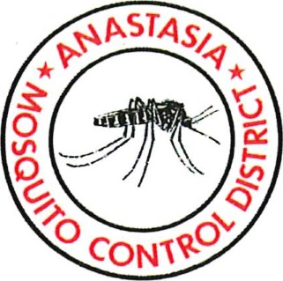
ANASTASIA MOSQUITO CONTROL DISTRICT
ST. JOHNS COUNTY
PROPOSED AGENDA

Thursday, December 11, 2025
5:00 P.M.
Invocation and Pledge: Commissioner Mrs. LeBlanc
Consent items: Approval of
- Treasurer’s report
- Vouchers/cancelled checks
- Chemical purchases and inventory
- Board Meeting Minutes of October 9 regular meeting
- Policy amendment for consent agenda (remove chemical inventory/purchase & Treasurer’s report/ cancelled checks to report, information & attachment based on the Board direction from last meeting, and effect from 2026 January Board meeting after approval)
- Switch 2026 January 8’s Board meeting to January 15 due to holidays
- Board meeting schedules in 2026 and board meeting time change from 5:00pm to 5:30pm from January 2026
- One year extension of the exploratory collaboration agreement with MosquitoMate on the new biopesticide (Wolbachia-infected male mosquitoes)

Unfinished Business:
- Speech about St. Johns County property value and tax perspective … Mr. Eddie Creamer, Property Appraiser, St. Johns County (15 minutes)
- Discussion and approval of health, dental, and life insurance renewal … Mr. Don Lohr, Herbie Wiles Ins Agent (15 minutes)
- Quarterly budget analysis … Mr. Scott Hanna, CFO (5 minutes)

New Business:
- Update and progress report about the MGT’s study on compensation … Mrs. Rivera, HRG (15 minutes)
- Board members for the FMCA Dodd short course (Commissioner Caucus, Gainesville, January 29, Thursday), Tallahassee legislation day (Feb 3/Tuesday), American Mosquito Control Association meeting (Portland, March 23-27, Monday -Friday), AMCA Washington DC Legislation meeting (May 11-14, Monday to Thursday) … Dr. Xue (15 minutes)

Reports:
Director
Attorney
Commissioners’ reports and comments:

Attachments: FMCA annual meeting report has been attached to the Director’s report.

